**Work Report**

**Date**: 16.9.24  
**Intern Name**: Rohan Kumar.A  
**Team Member**: Sarvesh Krishna.A.K  
**Task Title**: Website Update – Admin page viewing patient details and past appointments.

**Task Overview**:  
The assigned task was to update the admin page on the website that shows users details who requested a appointment and to view their past appointment history. The specific requirements were:

* Add an option for admin to view the user details.
* Add an option for admin to view the users past appointment history.
* Implement functional buttons to trigger these actions.

**Work Completed**:

1. **Design and Implementation of Buttons**:
   * Created the “View Details” button for displaying users' details.
   * Created the “View Past Appointment History” button for showing users’ past appointments.
2. **Functionality**:
   * Implemented the functionality for both buttons:
     + **View Details**: Retrieves the user's personal details and displays them on the page.
     + **View Past Appointment History**: Retrieves the user's past appointments and displays them on the page.
3. **Screenshots**:

Login to the admin panel:



New buttons added, “View Details”, ”View Past Appointments”:

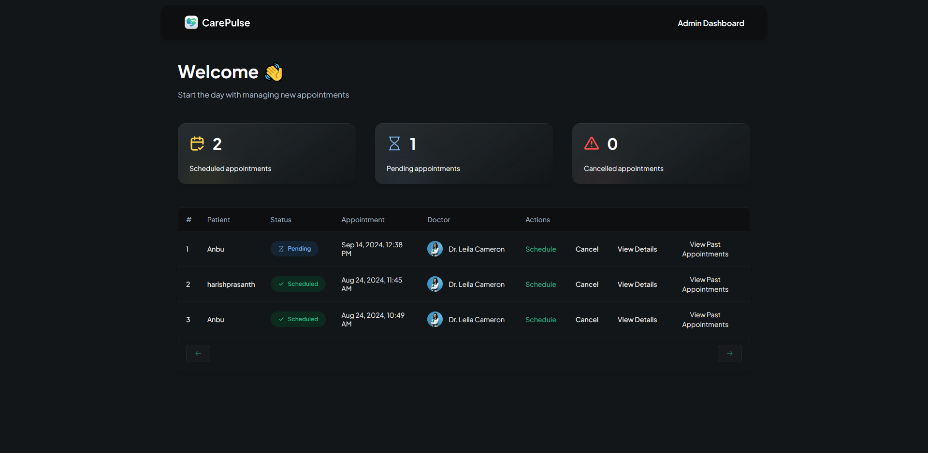

Functionality of “View Details” button:

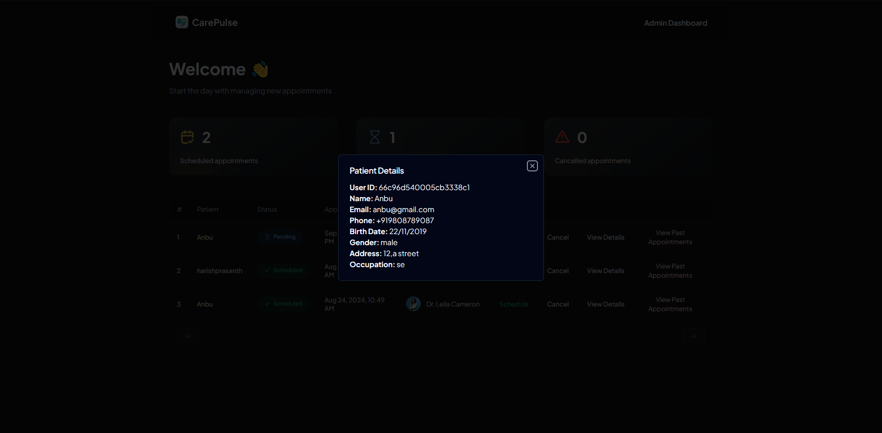

Functionality of “View Past Appointments” button:

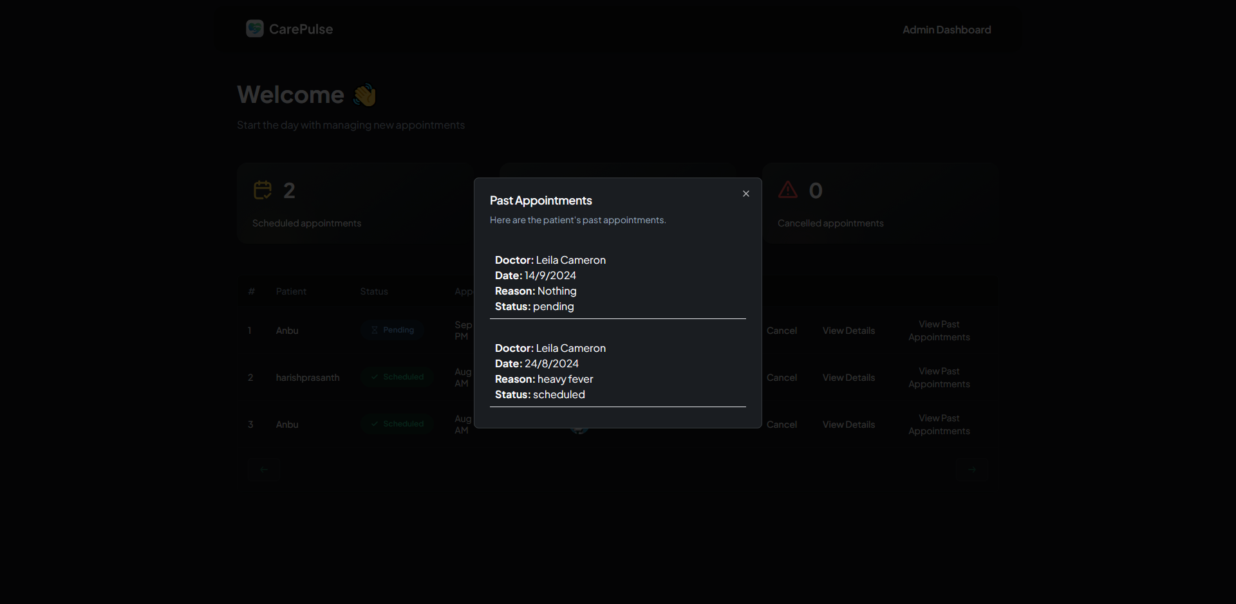

**Next Step**:

* To integrate our work with the work done by other team members to generate final output.